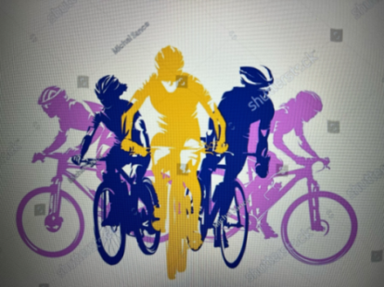
JOIN US FOR A BIKE RIDE
Rides are casual. Manual and E-Bikes welcome. No rider left behind, go your own speed
HELMETS REQUIRED
APRIL 18TH – Saturday 10:30 am – Led by Cathy Kaufman 805-915-7281
Marina Del Rey to Redondo Beach
Meet in the very far east end of parking lot of the El Torito Restaurant
(13715 Fiji Way). Parking cost is $4 for four hours!
Ride is very flat approximate total miles is 22. Eat at Captain Kidds
If you want to arrange for carpool, text Cathy a couple days before.

THERE IS NO MAY BIKE RIDE. Ride will take place on the Cachuma Lake
Camping trip.
JUNE BIKE RIDE DATE TO BE DETERMINED.


